Refer to the case on Page 123 of the text.
Read the case and answer the following questions:
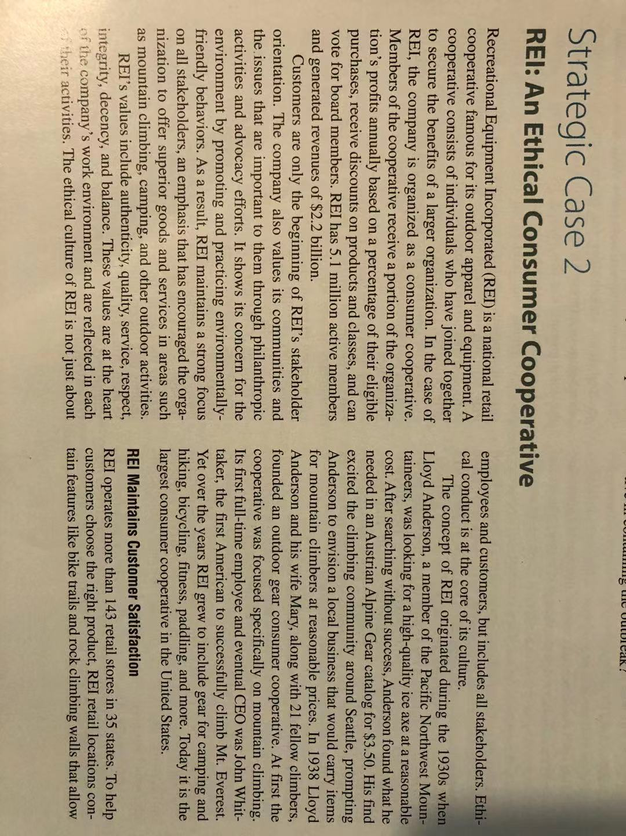
- Describe the Stakeholder orientation t REI.
- How does REI implement Social Responsibility?
- How do REI's values relate to the development of an ethical culture?

